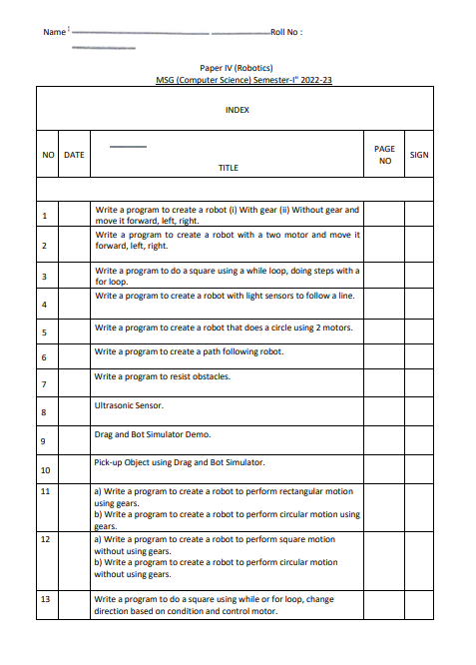

**PRACTICAL 1A**

**AIM**:WRITE A PROGRAM TO CREATE A ROBOT WITH GEAR AND MOVE IT FORWARD, LEFT, RIGHT.

Description:

1] NxtRobot() –

Class that represents a simulated NXT robot brick. Parts (e.g. motors, sensors) may be assembled into the robot to make it doing the desired job.

2] Gear() -

Creates a gear instance with right motor plugged into port A, left motor plugged into port B.

3] addPart(Part) -

Assembles the given part into the robot.

4] setSpeed(int) -

Sets the speed to the given value (arbitrary units).

5] forward() -

Starts the forward movement.

6] left() -

Starts to rotate left (center of rotation at middle of the wheel axes).

7] right() -

Starts to rotate right (center of rotation at middle of the wheel axes).

CODE:

import ch.aplu.robotsim.*;

public class Prac_1a {

Prac_1a(){

NxtRobot robot = new NxtRobot();

Gear g = new Gear();

robot.addPart(g);

g.setSpeed(100);

g.forward(500);

g.left(250);

g.forward(500);

g.right(250);

g.forward(500);

}

public static void main (String[] args) {

new Prac_1a();

}

}

OUTPUT:

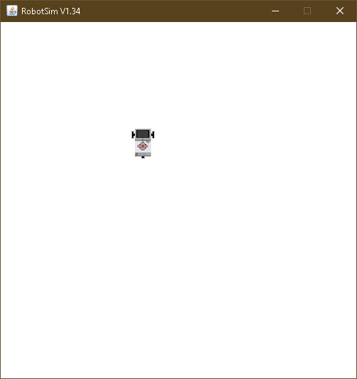

**PRACTICAL 1B**

**AIM**:WRITE A PROGRAM TO CREATE A ROBOT WITHOUT GEAR AND MOVE IT FORWARD, LEFT, RIGHT.

Description:

TurtleRobot() -

Creates a turtle robot instance.

CODE:

import ch.aplu.robotsim.*;

public class Prac_1b {

Prac_1b(){

TurtleRobot t = new TurtleRobot();

t.forward(100);

t.left(90);

t.forward(100);

t.right(90);

t.forward(100);

}

public static void main (String[] args) {

new Prac_1b();

}

}

OUTPUT:

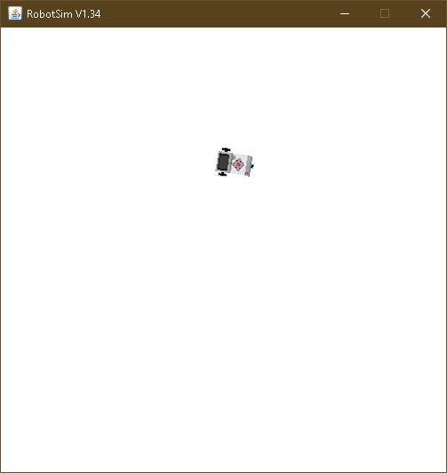

**PRACTICAL 2**

**AIM**:WRITE A PROGRAM TO CREATE A ROBOT WITH 2 MOTORS AND MOVE IT FORWARD, LEFT, RIGHT.

DESC:

1] Motor() -

Creates a motor instance that is plugged into given port.

2] Tools.delay() -

Suspends execution of the current thread for the given amount of time.

3] stop() –

Stops the rotation.

CODE:

import ch.aplu.robotsim.*;

public class Prac_2 {

Prac_2(){

NxtRobot r = new NxtRobot();

Motor m1 = new Motor(MotorPort.A);

Motor m2 = new Motor(MotorPort.B);

r.addPart(m1);

r.addPart(m2);

m1.forward();

Tools.delay(1090);

m2.forward();

Tools.delay(1090);

m1.stop();

m2.forward();

Tools.delay(1090);

m1.forward();

m1.stop();

m2.stop();

}

public static void main(String args[]){

new Prac_2();

}

}

OUTPUT:

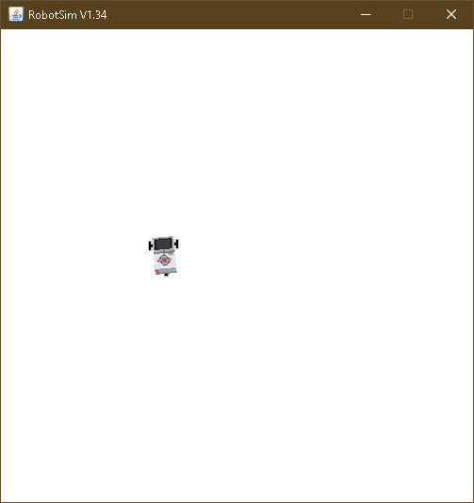

**PRACTICAL 3**

**AIM**:WRITE A PROGRAM TO DO A SQUARE USING A WHILE LOOP.

CODE:

import ch.aplu.robotsim.*;

public class Prac_3 {

Prac_3(){

NxtRobot robot = new NxtRobot();

Gear g = new Gear();

robot.addPart(g);

g.setSpeed(100);

while (true){

g.forward(600);

g.left(280);

}

}

public static void main (String[] args) {

new Prac_3();

}

}

OUTPUT:

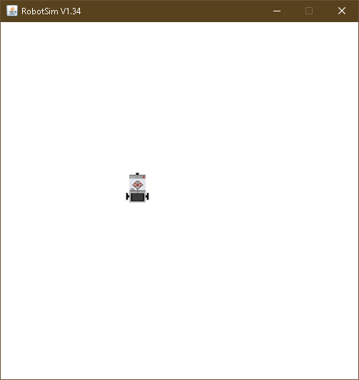

**PRACTICAL 4**

**AIM**:WRITE A PROGRAM TO CREATE A ROBOT WITH LIGHT SENSORS TO FOLLOW A LINE.

Description:

1] RobotContext() -

Creates a RobotContext instance.

2] setStartPosition(int, int) –

Sets the Nxt starting position (x-y-coordinates 0..500, origin at upper left).

3] useBackground(String) –

Use the given image as background (playground size 501 x 501).

4] LegoRobot() –

Creates a robot with its playground using defaults from RobotContext.

5] LightSensor(SensorPort) -

Creates a sensor instance pointing downwards connected to the given port.

6] getValue() –

For sensor ports 1, 2, 3, 4: returns the brightness of the background at the current location.

7] leftArc() –

Starts to move to the left on an arc with given radius.

8] rightArc() -

Starts to move to the right on an arc with given radius.

CODE:

import ch.aplu.robotsim.*;

public class Prac_4 {

static {

RobotContext.setStartPosition(32,495);

RobotContext.useBackground("sprites/road.gif");

}

Prac_4(){

LegoRobot r=new LegoRobot();

Gear g = new Gear();

LightSensor ls= new LightSensor(SensorPort.S3);

r.addPart(g);

r.addPart(ls);

g.forward();

g.setSpeed(50);

while(true){

int v =ls.getValue();

if(v < 100)

g.forward();

if(v > 350 && v<750)

g.leftArc(0.005);

if(v > 800)

g.rightArc(0.005);

}

}

public static void main (String args[]){

new Prac_4();

}

}

OUTPUT:

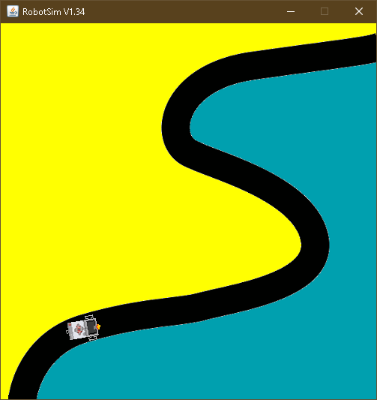

**PRACTICAL 5**

**AIM**:WRITE A PROGRAM TO CREATE A ROBOT THAT DOES A CIRCLE USING 2 MOTORS.

CODE:

import ch.aplu.robotsim.*;

public class Prac_5 {

Prac_5() {

NxtRobot r = new NxtRobot();

Motor A = new Motor(MotorPort.A);

Motor B = new Motor(MotorPort.B);

r.addPart(B);

r.addPart(A);

A.setSpeed(100);

B.setSpeed(100);

A.forward();

B.forward();

while (true){

Tools.delay(200);

A.stop();

Tools.delay(200);

A.forward();

}

}

public static void main(String arg[]) {

new Prac_5();

}

}

OUTPUT:

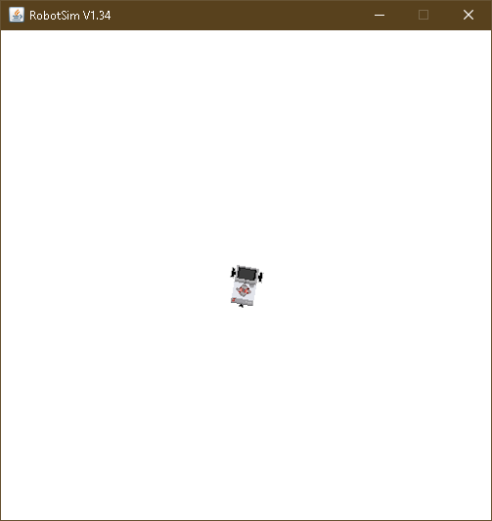

**PRACTICAL 6**

**AIM**:WRITE A PROGRAM TO CREATE A PATH FOLLOWING ROBOT.

Description:

1] setStartDirection(double) -

Sets the Nxt starting direction (zero to EAST).

CODE:

import ch.aplu.robotsim.*;

public class Prac_6 {

Prac_6(){

NxtRobot robot=new NxtRobot();

Gear gear=new Gear();

LightSensor ls1=new LightSensor(SensorPort.S1);

LightSensor ls2=new LightSensor(SensorPort.S2);

robot.addPart(gear);

robot.addPart(ls1);

robot.addPart(ls2);

gear.forward();

gear.setSpeed(100);

while(true)

{

int rightValue=ls1.getValue();

int leftValue=ls2.getValue();

if(leftValue < 10)

gear.rightArc(0.05);

if(rightValue < 10)

gear.leftArc(0.05);

if(leftValue > 10 && rightValue > 10)

gear.forward();

}

}

public static void main(String args[])

{

new Prac_6();

}

static

{

NxtContext.setStartPosition(267,232);

NxtContext.setStartDirection(-90);

NxtContext.useBackground("sprites/path.gif");

}

}

OUTPUT:

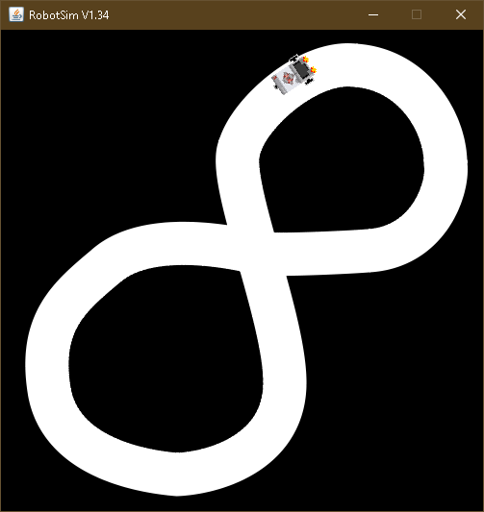

**PRACTICAL 7**

**AIM**:WRITE A PROGRAM TO RESIST OBSTACLES.

Description:

1] TouchSensor(SensorPort) -

Creates a sensor instance connected to the given port.

2] isPressed() –

Polls the touch sensor and returns true, if there is a collision with any of the collision obstacles.

3] backward() –

Starts moving backward and returns immediately.

4] useObstacle(Obstacle) –

Defines the given obstacle to be used as touch obstacle.

CODE**:**

import ch.aplu.robotsim.*;

public class Prac_7 {

Prac_7(){

LegoRobot r=new LegoRobot();

Gear g = new Gear();

TouchSensor t1= new TouchSensor(SensorPort.S1);

TouchSensor t2 = new TouchSensor(SensorPort.S2);

r.addPart(g);

r.addPart(t1);

r.addPart(t2);

g.forward();

g.setSpeed(50);

while(true){

Boolean b1 = t1.isPressed();

Boolean b2 = t2.isPressed();

if(b1 && b2){

g.backward(150);

g.right(400);

g.forward();

}

if(b1){

g.backward(150);

g.left(200);

g.forward();

}

if(b2){

g.backward(150);

g.right(200);

g.forward();

}

}

}

static {

RobotContext.setStartPosition(100,250);

RobotContext.useObstacle(RobotContext.channel);

}

public static void main(String args[]){

new Prac_7();

}

}

OUTPUT:

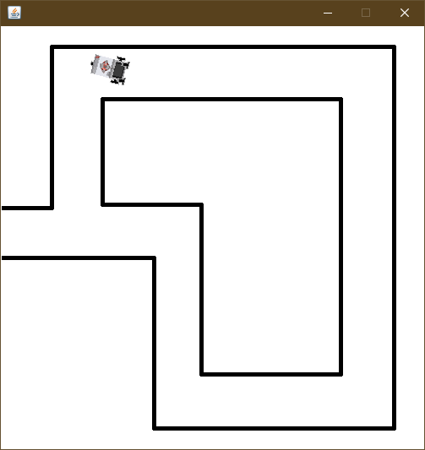

**PRACTICAL 8**

**AIM**:ULTRASONIC SENSOR.

DESC:

1] UltrasonicSensor(SensorPort) -

The port selection determines the position of the sensor and the direction of the beam axis.

2] setBeamAreaColor(Color) -

Sets the color of the beam area (two sector border lines and axis).

3] setProximityCircleColor(Color) –

Sets the color of the circle with center at sensor location and radius equals to the current distance value.

4] getDistance() –

Returns the distance to the nearest target object.

5] useTarget(String, Point[], int, int) –

Creates a target for the ultrasonic sensor using the given sprite image.

CODE:

import ch.aplu.robotsim.*;

import java.awt.Color;

import java.awt.Point;

public class Prac_8 {

Prac_8() {

LegoRobot robot = new LegoRobot();

Gear gear = new Gear();

robot.addPart(gear);

UltrasonicSensor us = new UltrasonicSensor(SensorPort.S1);

robot.addPart(us);

us.setBeamAreaColor(Color.green);

us.setProximityCircleColor(Color.lightGray);

double arc = 0.5;

gear.setSpeed(50);

gear.rightArc(arc);

boolean isRightArc = true;

int oldDistance = 0;

while (true)

{

Tools.delay(100);

int distance = us.getDistance();

if (distance == -1)

continue;

if (distance < oldDistance)

{

if (isRightArc)

{

gear.leftArc(arc);

isRightArc = false;

}

else

{

gear.rightArc(arc);

isRightArc = true;

}

}

oldDistance = distance;

}

}

static{

Point[] mesh_bar =

{

new Point(10, 200), new Point(-10, 200),

new Point(-10, -200), new Point(10, -200)

};

RobotContext.useTarget("sprites/bar1.gif", mesh_bar, 200, 250);

RobotContext.useTarget("sprites/bar1.gif", mesh_bar, 300, 250);

RobotContext.setStartPosition(250, 460);

}

public static void main(String[] args) {

new Prac_8();

}

}

OUTPUT:

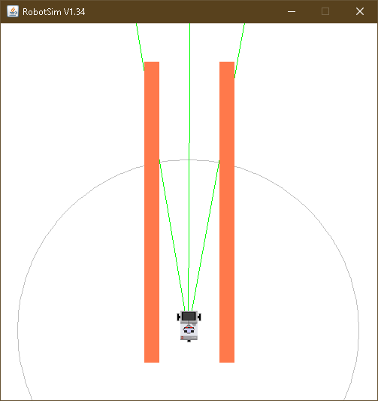

Assignment 1(A):

**AIM**: Write a program to create a robot to perform rectangular motion using gears

Description:

1] NxtRobot() :

Class that represents a simulated NXT robot brick. Parts (e.g. motors, sensors) may be assembled into the robot to make it doing the desired job.

2] Gear() :

Creates a gear instance with right motor plugged into port A, left motor plugged into port B.

3] addPart() :

Assembles the given part into the robot.

4] setSpeed() :

Sets the speed to the given value (arbitrary units).

5] forward() :

Starts the forward movement for the given duration (in ms) and stops. Method returns at the end of the given duration.

6] left() :

Starts to rotate left (center of rotation at middle of the wheel axes). Method returns immediately, while the movement continues

Code:

import ch.aplu.robotsim.NxtRobot;

import ch.aplu.robotsim.Gear;

public class assignment1A {

public assignment1A() {

NxtRobot r = new NxtRobot ();

Gear g = new Gear();

r.addPart (g);

g.setSpeed (100);

while (true){

g.forward (800);

g.left (280);

}

}

public static void main (String [] args){

new assignment1A ();

}

}

Output:

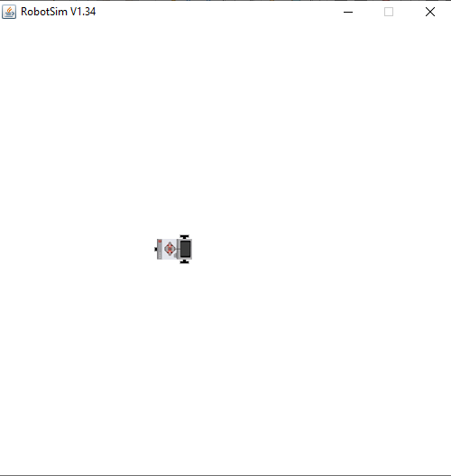

Assignment 1(B):

**AIM**: Write a program to create a robot to perform circular motion using gears

Description:

1] rightArc() :

Starts to move to the right on arc with given radius. Method returns immediately, while the movement continues.

.

Code:

import ch.aplu.robotsim.NxtRobot;

import ch.aplu.robotsim.Gear;

public class assignment1B {

public assignment1B () {

NxtRobot r = new NxtRobot ();

Gear g = new Gear ();

r.addPart (g);

g.setSpeed (100);

while (true) {

g.rightArc (0.5);

}

}

public static void main (String [] args){

new assignment1B ();

}

}

Output:

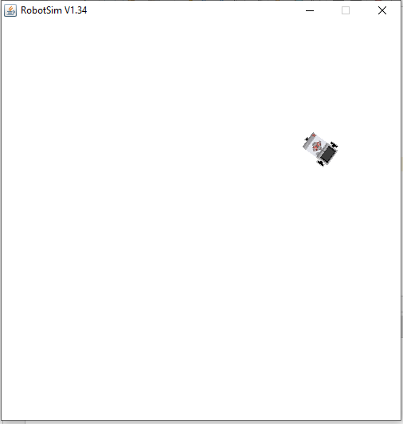

Assignment 2 (A):

**AIM**: Write a program to create robot to perform a square motion without using gear.

Code:

import ch.aplu.robotsim.*;

public class Assignment_2a {

Assignment_2a () {

TurtleRobot t = new TurtleRobot ();

t.setTurtleSpeed (100);

while (true){

t.forward(200);

t.left (90);

}

}

public static void main (String [] args) {

new Assignment_1a ();

}

}

Output:

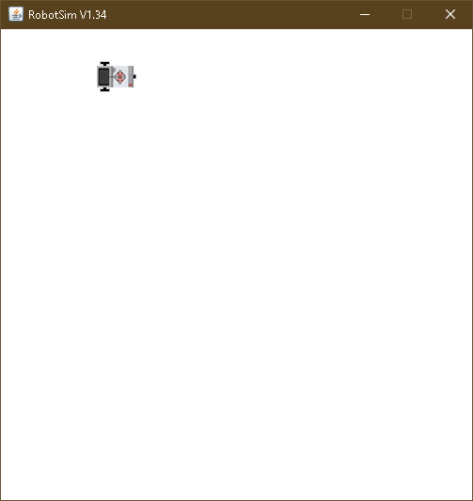

Assignment 2 (B):

**AIM**: Write a program to create robot to perform a circular motion without using gear.

Code:

import ch.aplu.robotsim.*;

public class Assignment_2b {

Assignment_2b () {

TurtleRobot t = new TurtleRobot ();

t.setTurtleSpeed (100);

while (true) {

t.forward (2);

t.left (2);

}

}

public static void main (String [] args) {

new Assignment_1b ();

}

}

Output:

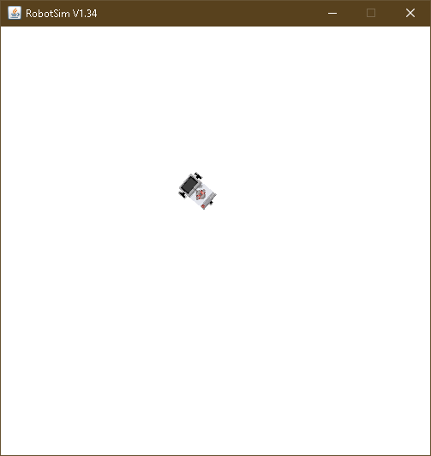

Assignment 3:

**AIM**: Write a program to do a square using while or for loop, change direction based on condition and control motor movement

Description:

1] Motor() :

Creates a motor instance that is plugged into given port.

2] Tools.delay() :

Suspends execution of the current thread for the given amount of time.

Code:

import ch.aplu.robotsim.*;

import java.util.*;

public class assignment2 {

assignment2 () {

Scanner sc = new Scanner (System.in);

NxtRobot r = new NxtRobot ();

Motor m1 = new Motor (MotorPort.A);

Motor m2 = new Motor (MotorPort.B);

r.addPart (m1);

r.addPart (m2);

System.out.println ("Enter 1 for left and 2 for right :");

int direction = sc.nextInt ();

switch (direction) {

case 1:

for (int i=0; i<4; i++){

m1.forward ();

Tools.delay (1090);

m2.forward ();

Tools.delay (1090);

m1.stop ();

m2.stop ();

}

break;

case 2:

for (int i=0; i<4; i++){

m2.forward ();

Tools.delay (1090);

m1.forward ();

Tools.delay (1090);

m1.stop ();

m2.stop ();

}

break;

}

}

public static void main (String args[]){

new assignment2 ();

}

}

Output:

